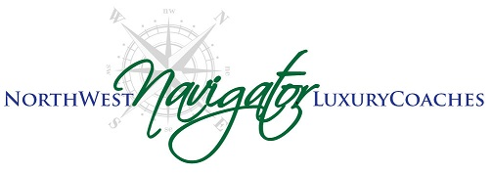

NWN MOTORCOACH OPERATOR CODE OF CONDUCT- AMWAY GROUP October/2017

Per NWN Policies and Procedures employee manual (found in your SMS Training system)
We received reports from our last Amway charter from our onboard contacts that these policies were not adhered to. Please review the following NWN policies for all charters:

- Navigator Motorcoach Operators are to load/store/unload luggage for ALL groups EVERY charter; passengers are NOT to load/unload their own luggage from bays

- Navigator Motorcoach Operators are to be at the bottom of the stairs to assist passengers ascending and descending the stairs every time

- These groups are allowed to sing on board- please expect it and plan accordingly

These policies were created for passenger safety and client service. We are a company that promises Excellence in Service | Reliability | Luxury | Safety
Our clients expect exceptional service from us. Please remember that you are ambassadors for NW Navigator and deviations from company policy will not be tolerated.

Thank you,
Joe and Roxanne Gillis

